Day 3->hacker rank
Task 1
You are given the firstname and lastname of a person on two different lines. Your task is to read them and print the following:
Hello firstname lastname! You just delved into python.
Function Description
Complete the print_full_name function in the editor below.
print_full_name has the following parameters:
- string first: the first name
- string last: the last name
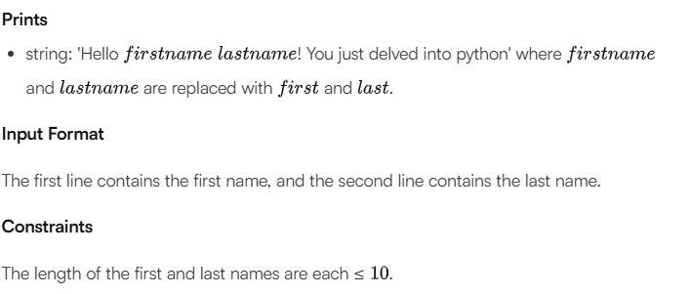
Input Format
The first line contains the first name, and the second line contains the last name.
Constraints
The length of the first and last names are each ≤10 .
Sample Input 0
Ross
Taylor
Sample Output 0
Hello Ross Taylor! You just delved into python.
Explanation 0
The input read by the program is stored as a string data type. A string is a collection of characters.
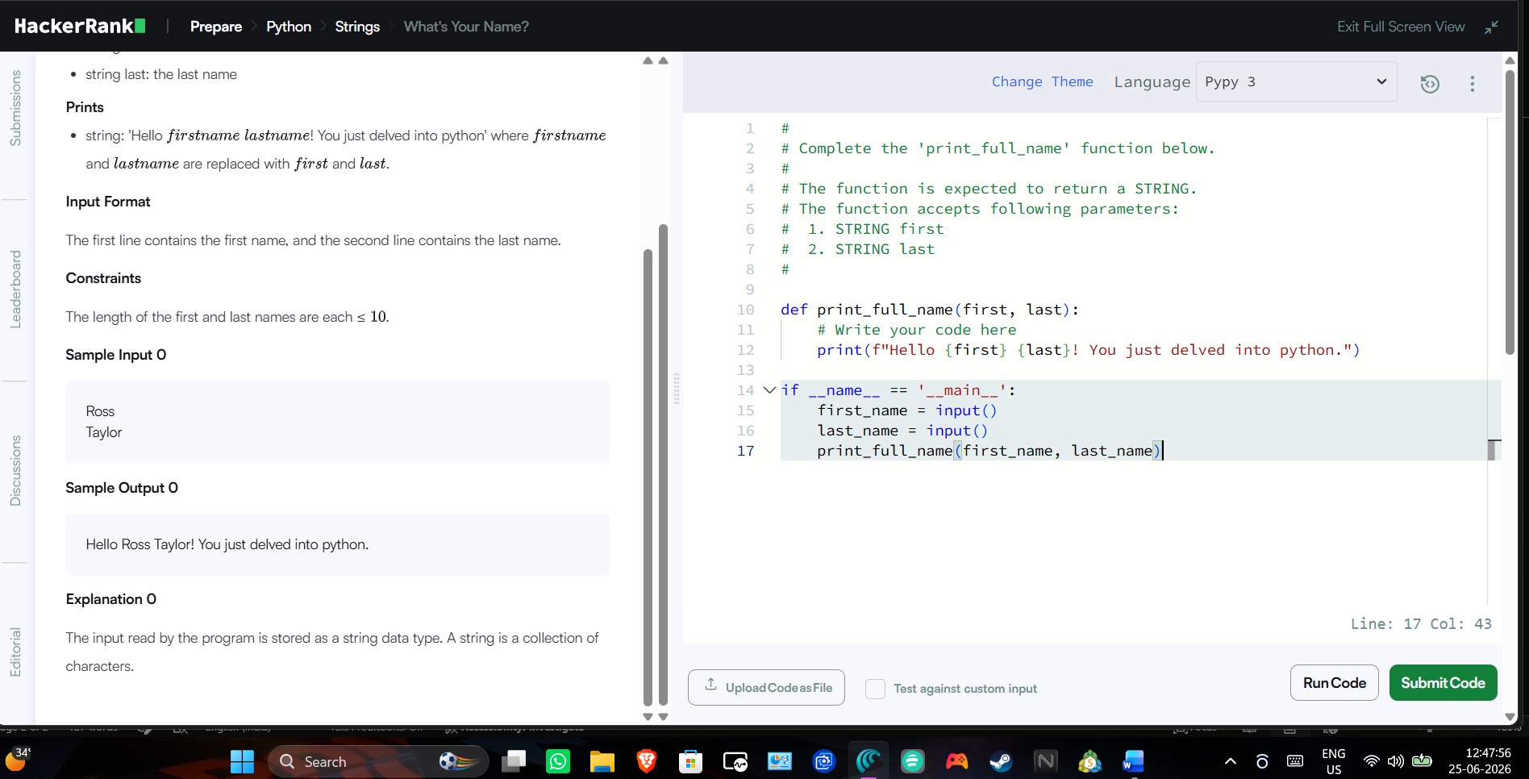
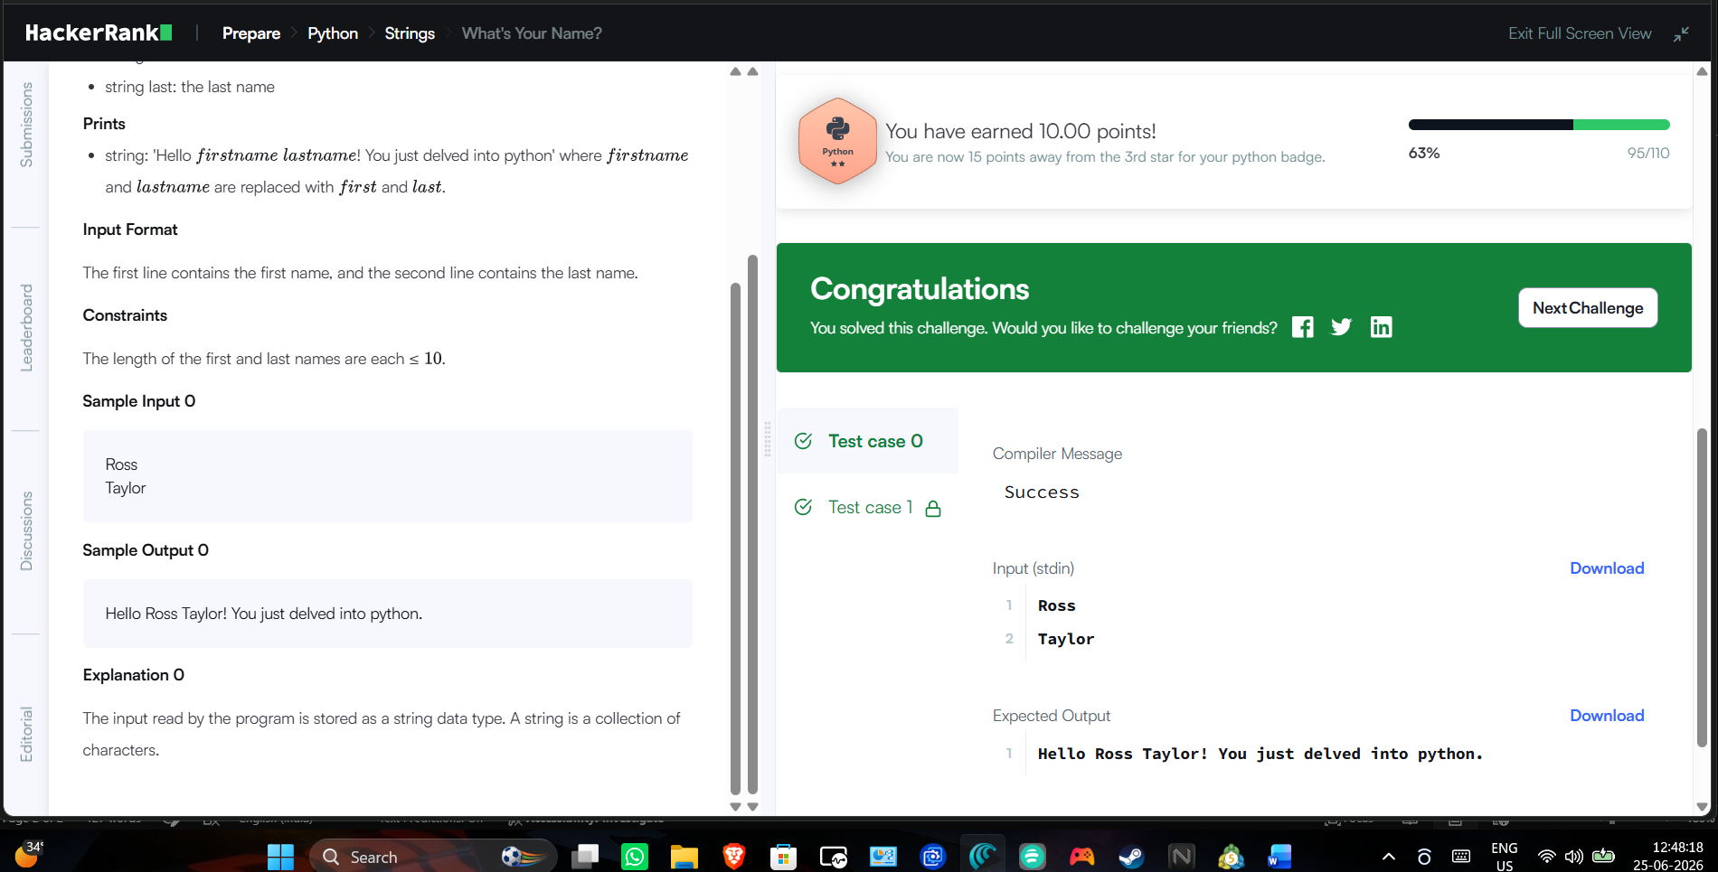
Task 2
Read a given string, change the character at a given index and then print the modified string.
Function Description
Complete the mutate_string function in the editor below.
mutate_string has the following parameters:
- string string: the string to change
- int position: the index to insert the character at
- string character: the character to insert
Returns
- string: the altered string
Input Format
The first line contains a string, String.
The next line contains an integer ,position the index location and a string , separated by a space.
Sample Input
STDIN Function
----- --------
abracadabra s = 'abracadabra'
5 k position = 5, character = 'k'
Sample Output
Abrackdabra
Explaination:
We have seen that lists are mutable (they can be changed), and tuples are immutable (they cannot be changed).
Let's try to understand this with an example.
You are given an immutable string, and you want to make changes to it.
Example
>>> string = "abracadabra"
You can access an index by:
>>> print string[5]
a
What if you would like to assign a value?
>>> string[5] = 'k'
Traceback (most recent call last):
File "<stdin>", line 1, in <module>
TypeError: 'str' object does not support item assignment
How would you approach this?
- One solution is to convert the string to a list and then change the value.
Example
>>> string = "abracadabra"
>>> l = list(string)
>>> l[5] = 'k'
>>> string = ''.join(l)
>>> print string
abrackdabra
- Another approach is to slice the string and join it back.
Example
>>> string = string[:5] + "k" + string[6:]
>>> print string
abrackdabra
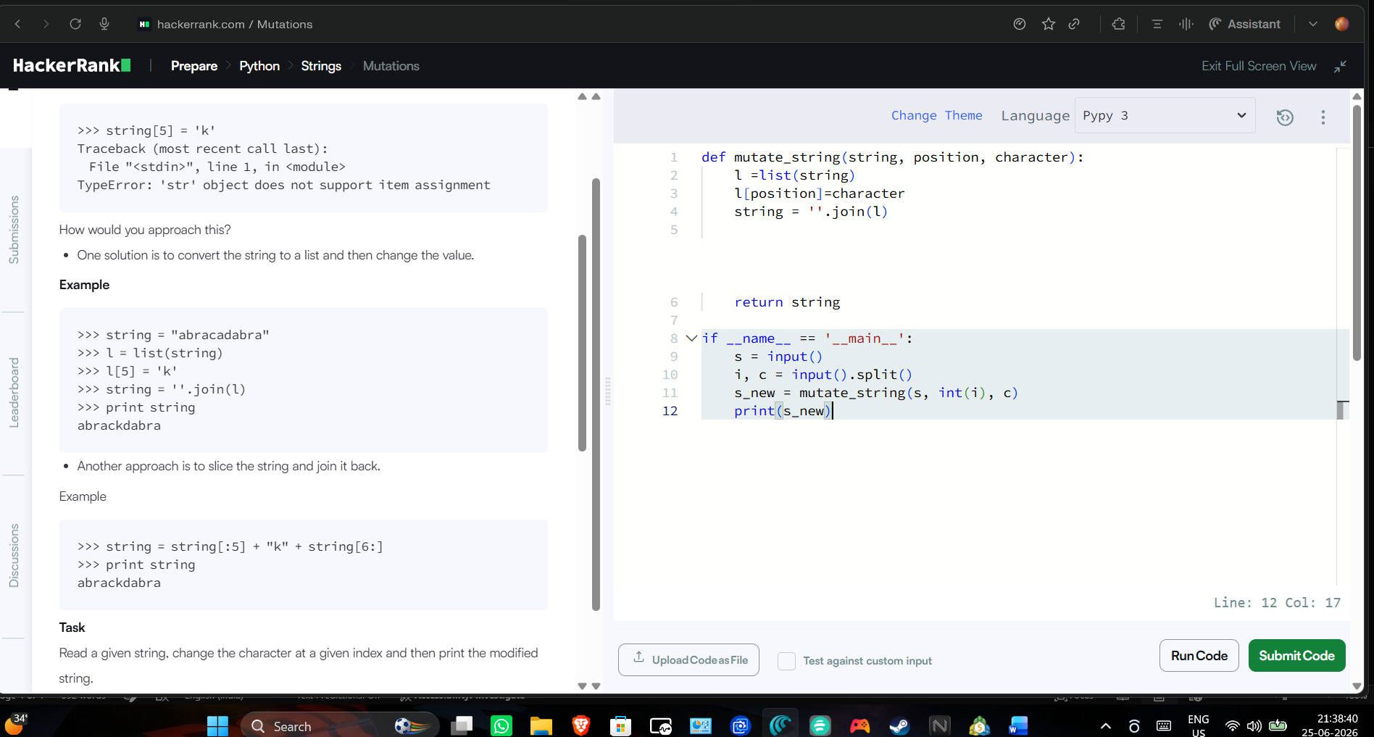
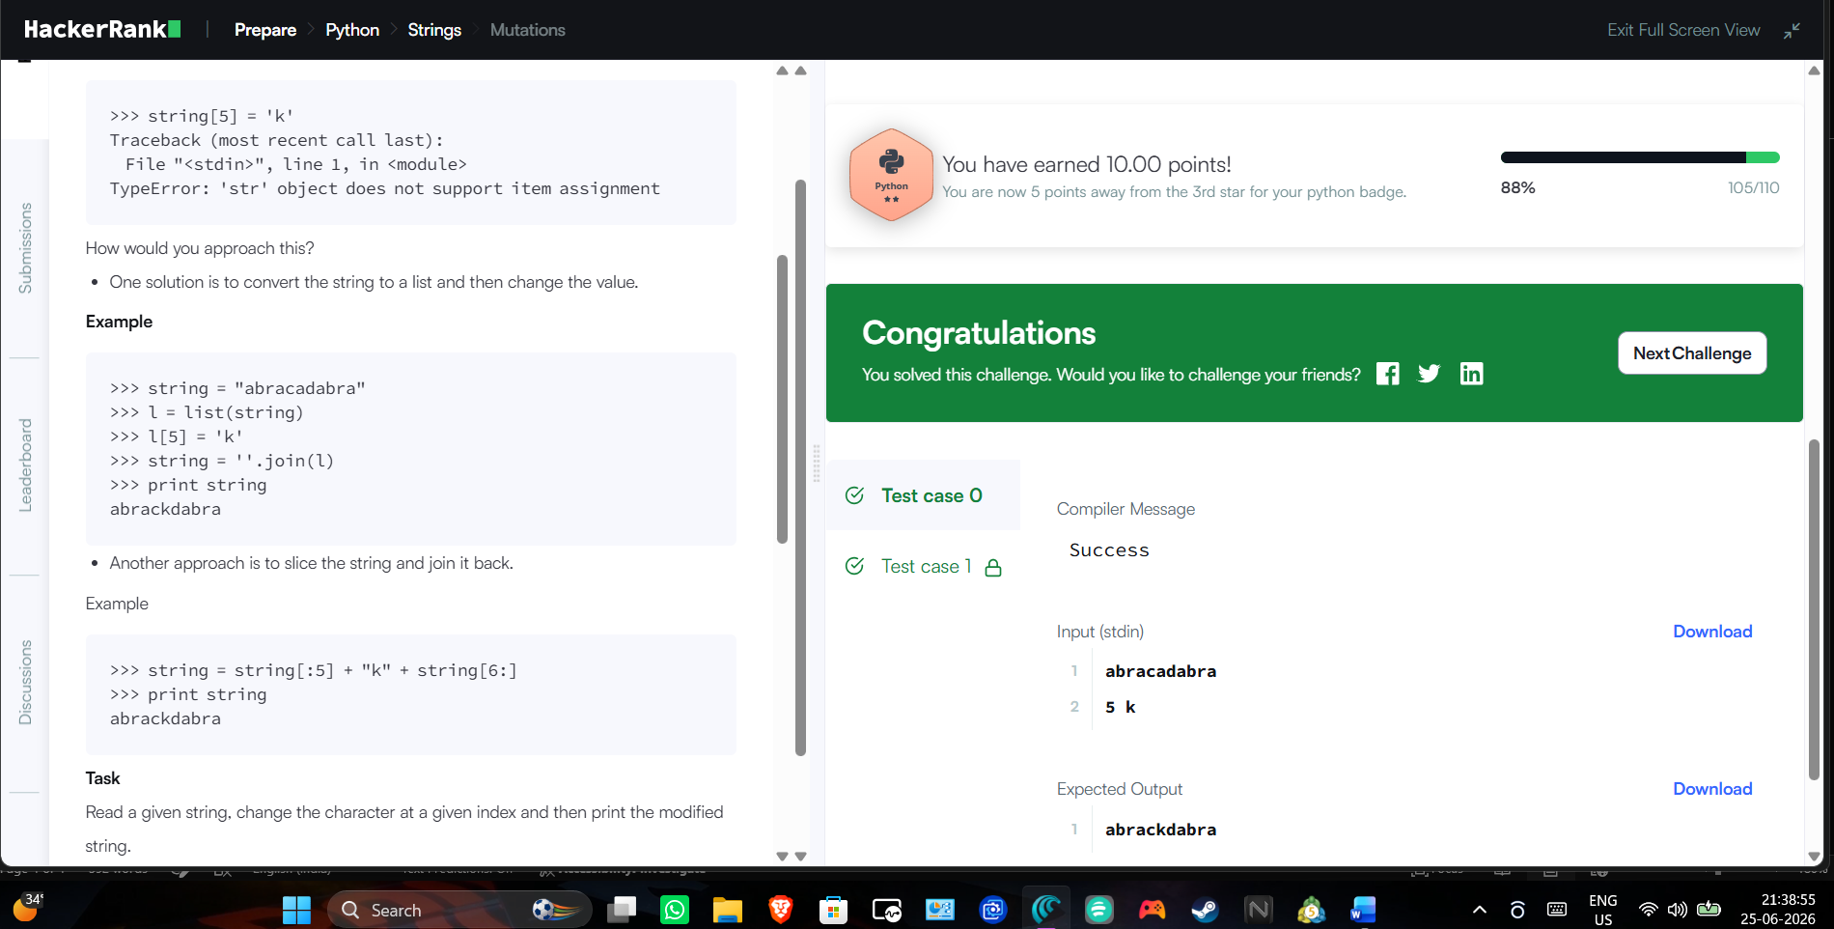

Task 3
In this challenge, the user enters a string and a substring. You have to print the number of times that the substring occurs in the given string. String traversal will take place from left to right, not from right to left.
NOTE: String letters are case-sensitive.
Input Format
The first line of input contains the original string. The next line contains the substring.
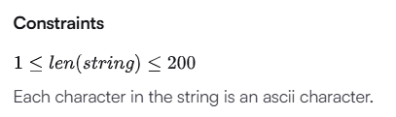
Output Format
Output the integer number indicating the total number of occurrences of the substring in the original string.
Sample Input
ABCDCDC
CDC
Sample Output
2
Concept
There are a couple of new concepts:
In Python, the length of a string is found by the function len(s), where is the string.
To traverse through the length of a string, use a for loop:
for i in range(0, len(s)):
print (s[i])
A range function is used to loop over some length:
range (0, 5)
Here, the range loops over to . is excluded.
